Devan Registration usability guide

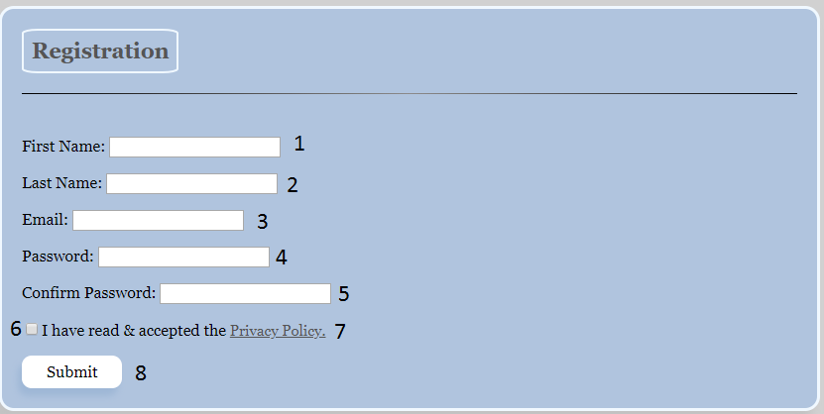

1. Textbox to enter your first name, this is required
2. Textbox to enter your last name, this is required
3. Textbox to enter your email, this is required and will be validated
4. Textbox to enter your password, this is required
5. Textbox to confirm your password, this is required
6. Checkbox to confirm that you have accepted the Privacy Policy, this is required
7. Privacy Policy link, if clicked will open the Privacy Policy for you to read
8. Submit button, all fields will be validated when this is pressed and if everything is good, your information and account will be saved into the database and you will be redirected and automatically logged in. If anything is missing or validation fails, the page will alert you to what is needed.